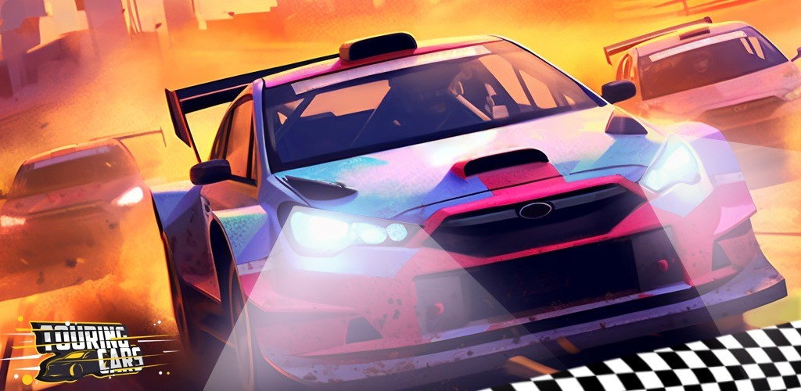

Touring Cars

Welcome to the world of touring cars. Buckle up and set off in your high-end sports car down the track. Avoid objects and obstacles on the track and get as far as you can to become the touring car champion.